**SHIMONI DEMONSTRATION -KIRA**

**MID TERM EXAMINATIONS, 2024**

**P.2 LITERACY II**

**NAME-----------------------------------------------------------**

1. Write the first sound of these objects.

|  |  |  |  |
| --- | --- | --- | --- |
|  |  |  |  |
|  |  |  |  |

2. Form the words correctly

a) le-g __________________ b) do-ll ________________

c) g-oa-t _________________ d) re-d ________________

e) b-ir-d ______________________

3. Write the two days of the week which begin with sound **S**

a) ________________________

b) ______________________

4. Underline the odd man out.

a) sheep duckling goat pig

b) nose desk leg hands

c) shirt ruler book pencil

5. Fill in sound: ee o-e, ea, ir, oo

a) f____t b) th____ty c) m___t d) t_____th

**SECTION B**

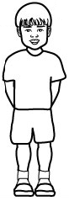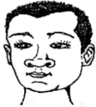6. **Join and form one word**

+ = ___________________

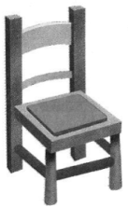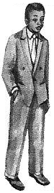

+ = __________________

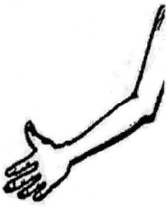

+ = ________________

7. **Write words with these sounds**

ai _____________________ gl__________________

s_______________________ gr__________________

10. **Match the rhyming word.**

cart firm

still hat

hut cut

farm steel

cart ____________

still ____________

hut ____________

farm ____________

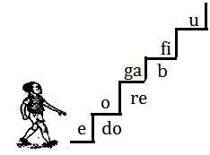

11. **Kapata’s reading ladder**

a) Write any two vowel letters from Kapata’s reading ladder.

_____________________ _________________

b) Write any three syllables from Kapata’s reading ladder.

_____________, _____________, ____________

13. **Underline the word for the given sound.**

oa goat log face

ee goose duckling geese

igh fingers thigh feelers

i-e friend kite ball

14. **Read the story and answer the questions in full sentences**

**A dog**

A dog is a domestic animal.

It guards our home.

It lives in a kennel.

It barks at strangers who always come at home.

A dog eats bones.

**By Mary**

a) What is the title of the story?

________________________________________________________

b) Where does a dog live?

________________________________________________________

c) Write words with these sounds.

ar_______________________ ke_________________________

d) Who wrote the story?

________________________________________________________

15. **Answer correctly**

a) I have four legs,

I live in people’s homes,

I chase and eat rats.

I am a _______________

b) People use me to bath,

wash their clothes and utensils.

What am I ? _______________

16. **Copy and write neatly.**



Cc Cc Cc Cc

cock cook camel

Charles can eat a carrot.

A cockroach has six legs.